## Chapter 1

**Introduction**

* 1. **Outline**

Every organization, whether big or small, has human resource challenges to overcome. Every

organization has different employee management needs, therefore we design exclusive employee management systems that are adapted to your managerial requirements. This is designed to assist in strategic planning, and will help you ensure that your organization is equipped with the right level of human resources for your future goals. Also, for those busy executives who are always on the go, our systems come with remote access features, which will allow you to manage your workforce anytime, at all times. These systems will ultimately allow you to better manage resources. One of the main features in employee management system is time tracking for employees. Effective time tracking mechanism saves both time and money for the organization.

**1.2 Motivation and Scope**

In this world of growing technologies everything has been computerized. With large number of work opportunities the Human workforce has increased. Thus, there is a need of a system which can handle the data of such a large number of Employees in an organization. This project simplifies the task of maintain records because of its user-friendly nature.

These systems will ultimately allow you to better manage resources. One of the main features in employee management system is time tracking for employees. Effective time tracking mechanism saves both time and money for the organization.

* 1. **PROBLEM STATEMENT**

Design and develop friendly user interface of a Employee management System where the admin can add, check details and requests of employee. Employee can check his details and can send requests of employee after proper authentication.

* 1. **LIMITAIONS**
* This application cannot be accessed through online.
* This application is not connected to printer.
* More advanced software can be used(anugular.js).
* This application is not secured.
* Only DBA can add new manager to the application.

**Chapter 2**

**Requirements Specification**

**2.1 Functional Requirements:**

**Manager and user login:**

After proper authentication the manager and user can login. Manager can see the details of employees who are working under him. User can check his details.

**Add Employees:**

After proper authentication the manager can add new employees. He also add details of employee details like designation, address, salary, DOB, experience.

**Request by Employee:**

After proper authentication the employee can request his respective manager for leave. It can be done by using leave form in the user login of the application.

**Accept or Reject by Manager:**

The manager can accept or reject the requests sent by employees for leave permission.

**Delete employee:**

The manager can delete employee from the database. It deletes all the details such as experience details from the database permanently.

**Checking status:**

The user and manager can check status of leave whether it has been accepted or rejected by manager.

**2.2** **Non-functional Requirements**

**Performance:**

Response time of the Employee management system should be less than 2 second most of the time. Response time refers to the waiting time while the system accesses, queries and retrieves the information from the databases (DB-user, DB-schedule etc) (A local copy of employee database is maintained as DB-schedule to reduce this access time)

ARS shall show no visible deterioration in response time as the number of users increases.

**Reliability:**

EMS shall be available 24 hours a day, 7 days a week

EMS shall always provide real time information about employee information. EMS shall be robust enough to have a high degree of fault tolerance. For example, if the user enters a wrong user id or password, the system should not crash and shall identify the invalid input and produce a suitable error message.

**Usability:**

EMS shall provide a easy-to-use graphical interface similar to other existing employee management system so that the users do not have to learn a new style of interaction. Any notification or error messages generated by EMS shall be clear, succinct, polite and free of jargon.

**Integrity**

Only system administer has the right to change system parameters, such as adding new managers etc. The system should be secure and must use encryption to protect the databases.

Users need to be authenticated before having access to any personal data.

**2.3 Domain Constraints**

**Regulatory policies**: It is a mandatory that no text book must be left empty or contains insufficient data.

**Hardware limitations**: There must be a 64 MB on board memory

**Control functions:** The software must be very user-friendly and display appropriate error messages.

**Interfaces to other applications**: Not applicable.

**Parallel operations:** It must support many users simultaneously.

**Safety/security considerations:** The application must be exited always normally.

Higher order language requirements: VB

**Chapter 3**

**System/Requirements Analysis**

**3.1 Overall system description:**

employee

manager

**Fig. 3.1: Overall System Design**

The overall system is as follows:

The are two logins: Manager login and Employee login

After proper authentication, the manager can add new employee, delete employee, update his own password and also can respond to his employee requests for leave. The manager can maintain only the employees working under him

After proper authentication, the employee can check his details, can send request for the leave to

his manager, check the response status.

**3.2 Component/subsystem design:**

**Display module:**

manager

**Fig. 3.2: Display process flow diagram**

This display module displays the employee details who are working under him. Bootstrap tables are used for good UI experience. No records are displayed if no employees are found.

**Register module:**

manager

**Fig. 3.3: Register process flow diagram**

In this register module, the manager can add new employees. He can add details like employee name, gender, phone no, designation, salary, address, email and experience details such as company, designation, years of experience. HTML validations are added, hence it will display

error message requesting required format.

**Request module:**

manager

**Fig. 3.4: Request process flow diagram**

In requests module, the manager can respond to the leave requests sent by the employee. By using reqno the manager can either can accept or request to the leave. The manager can modify the requests at any time.

**Delete module:**

manager

**Fig. 3.5: Delete process flow diagram**

In the delete module, it will pop up a bootstrap modal where we have to enter employee id to delete a record. The details of employee are permanently deleted from the database.

**Chapter 4**

**SYSTEM DESIGN**

**Entity Relationship Diagram:**

An entity–relationship model describes interrelated things of interest in a specific domain of knowledge. A basic ER model is composed of entity types and specifies relationships that can exist between instances of those entity types.

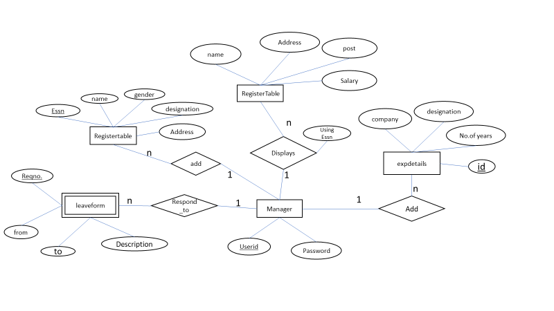

**Fig.4.1 ER Diagram**

**Schema Diagram:**

The Data Model describes the conceptual data organization of the Web Ratio applications; it is compatible with the Entity-Relationship model and UML class diagrams. An Entity-Relationship Model (ERM) is an abstract and conceptual representation of data. Entity-relationship modelling is a database modelling method, used to produce a type of conceptual schema or semantic data model of a system, often a relational database, and its requirements in a top-down fashion.

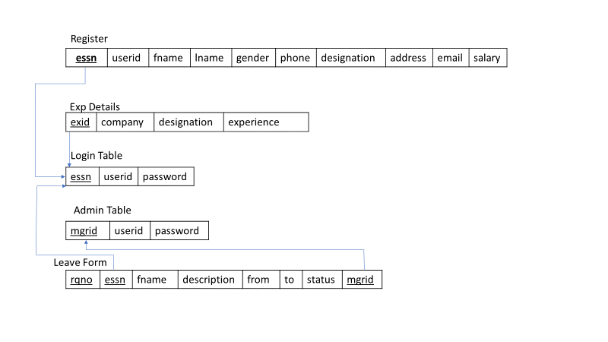

**Fig.4.2 Schema Diagram**

## Data Model :

A data model is an abstract model that organizes elements of data and standardizes how they relate to one another and to properties of the real-world entities. For instance, a data model may specify that the data element representing a car be composed of a number of other elements which, in turn, represent the colour and size of the car and define its owner.

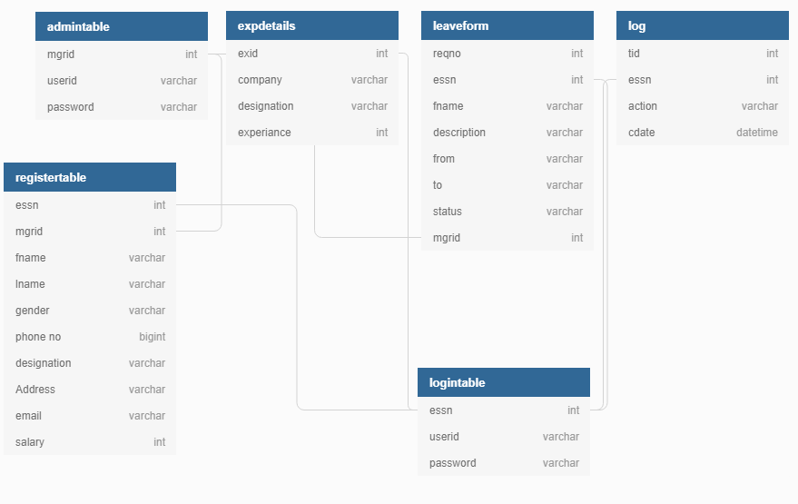

## Chapter 5

**Implementation**

**5.1 Description of Database Used**

MySQL is an [open source](https://en.wikipedia.org/wiki/Open-source_software) [relational database management system](https://en.wikipedia.org/wiki/Relational_database_management_system) (RDBMS). Its name is a combination of "My", the name of co-founder [Michael Widenius](https://en.wikipedia.org/wiki/Michael_Widenius)'s daughter, and "[SQL](https://en.wikipedia.org/wiki/SQL)", the abbreviation for [Structured Query Language](https://en.wikipedia.org/wiki/Structured_Query_Language). The MySQL development project has made its [source code](https://en.wikipedia.org/wiki/Source_code) available under the terms of the [GNU General Public License](https://en.wikipedia.org/wiki/GNU_General_Public_License), as well as under a variety of [proprietary](https://en.wikipedia.org/wiki/Proprietary_software) agreements. MySQL was owned and sponsored by a single [for-profit](https://en.wikipedia.org/wiki/Business) firm, the [Swedish](https://en.wikipedia.org/wiki/Sweden) company [MySQL AB](https://en.wikipedia.org/wiki/MySQL_AB), now owned by [Oracle Corporation](https://en.wikipedia.org/wiki/Oracle_Corporation). For proprietary use, several paid editions are available, and offer additional functionality.

**5.2 Description of Integrated Development Environment**

**PhpMyAdmin:**

phpMyAdmin is one of the most popular applications for MySQL database management. It is a free tool written in PHP. Through this software you can create, alter, drop, delete, import and export MySQL database tables. You can run MySQL queries, optimize, repair and check tables, change collation and execute other database management commands.

All the SiteGround clients can manage their MySQL databases through the pre-installed phpMyAdmin software which is integrated in cPanel.

**Version: phpMyAdmin (4.8.2)**

**Sublime Text:**

Sublime Text is a proprietary cross-platform source code editor with a Python application programming interface. It natively supports many programming languages and markup languages, and functions can be added by users with plugins, typically community-built and maintained under free-software licenses.

**Version: Sublime Text (3.1.1)**

**Chapter 6**

**Interpretation of Results**

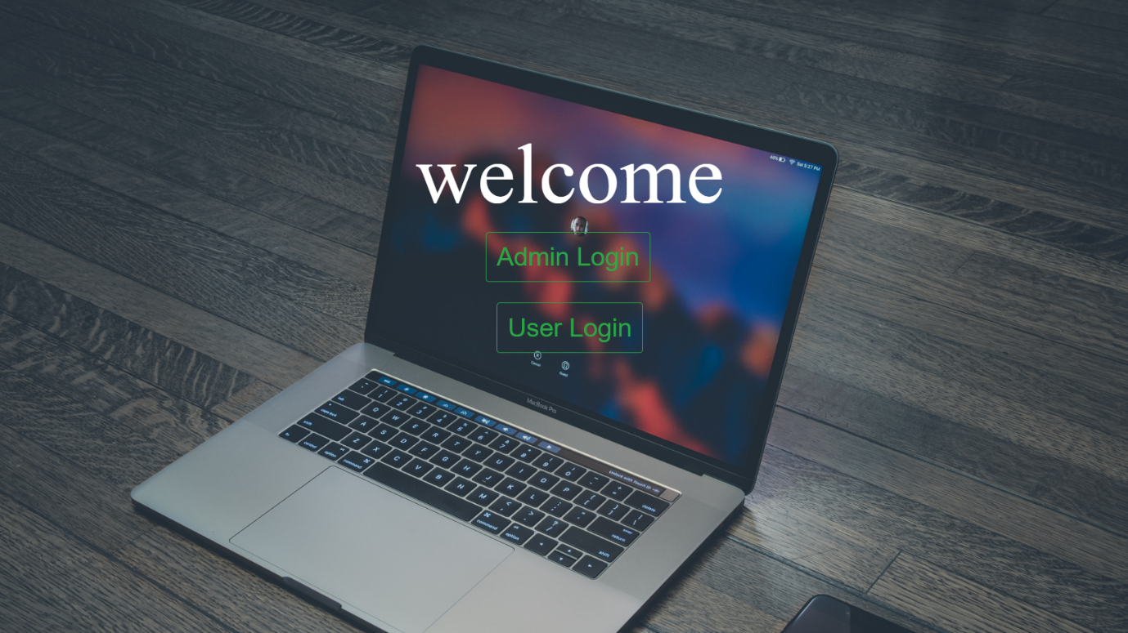

**Fig.6.1: Welcome Window**

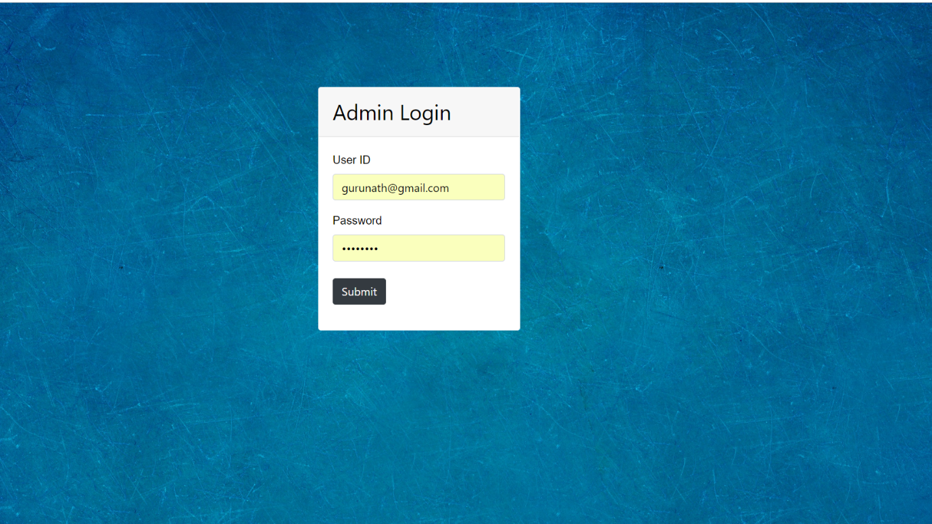

**Fig.6.2: Admin Login Window**

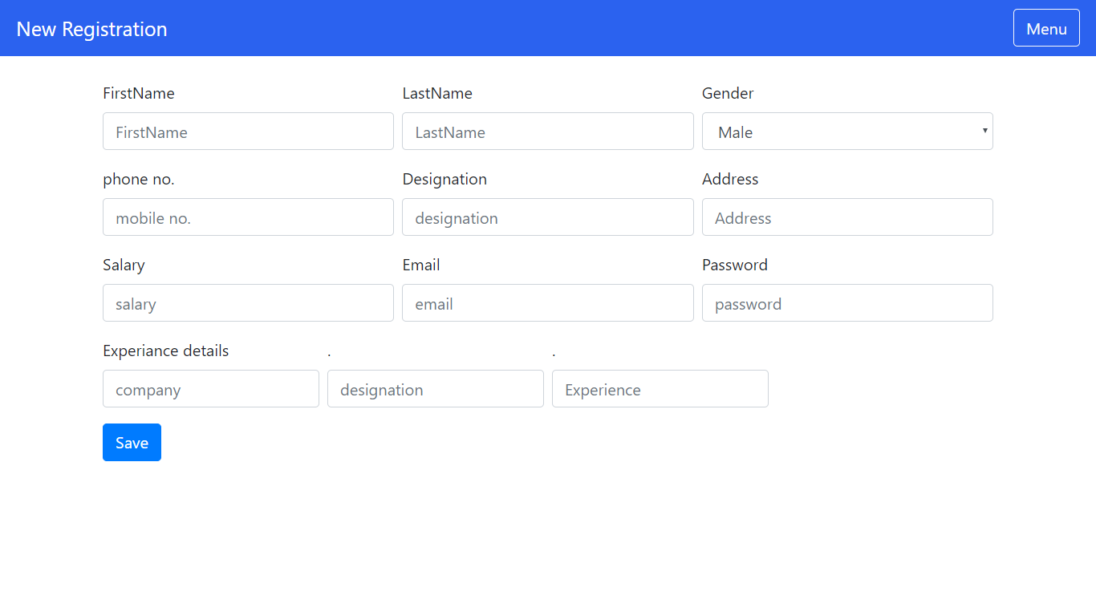 **Fig 6.3: Registration Window**

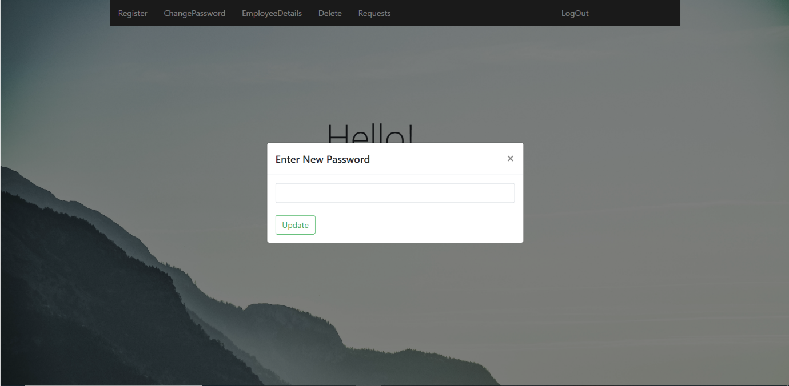

**Fig 6.4: New Password Window**

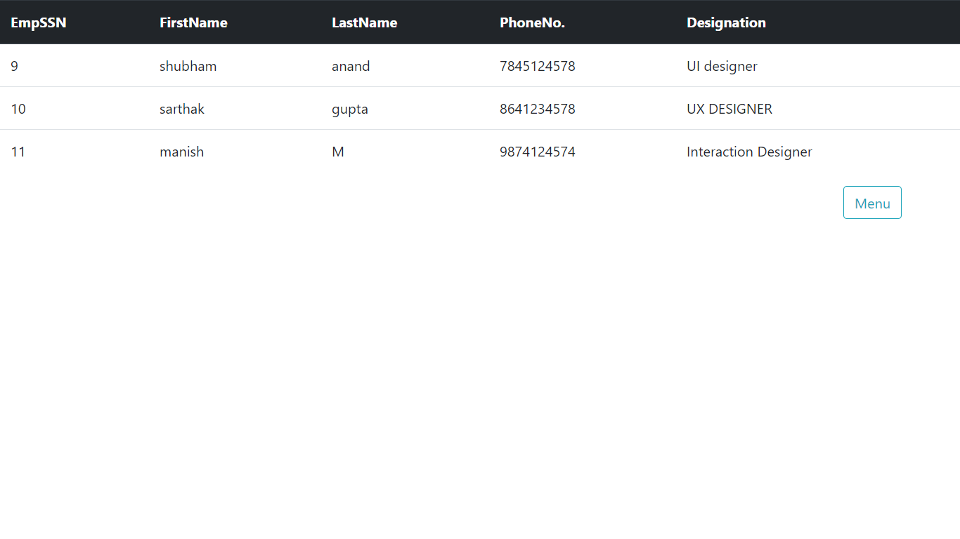

**Fig .6.5: Employee Details Window**

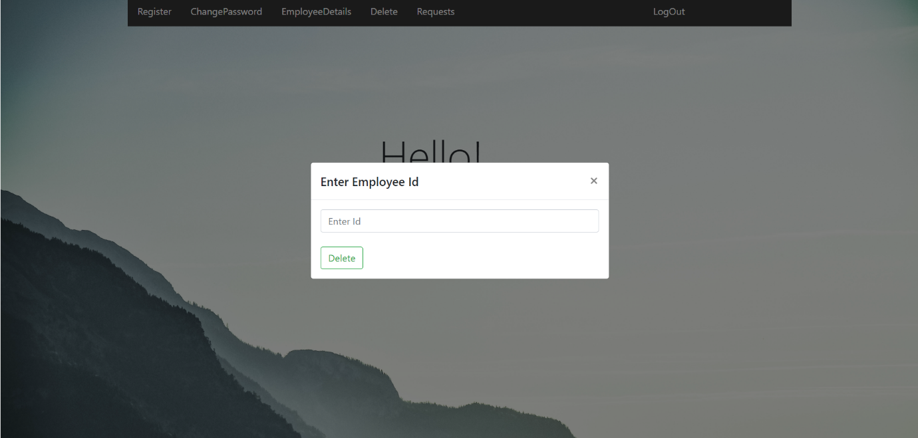

**Fig.6.6: Delete Window**

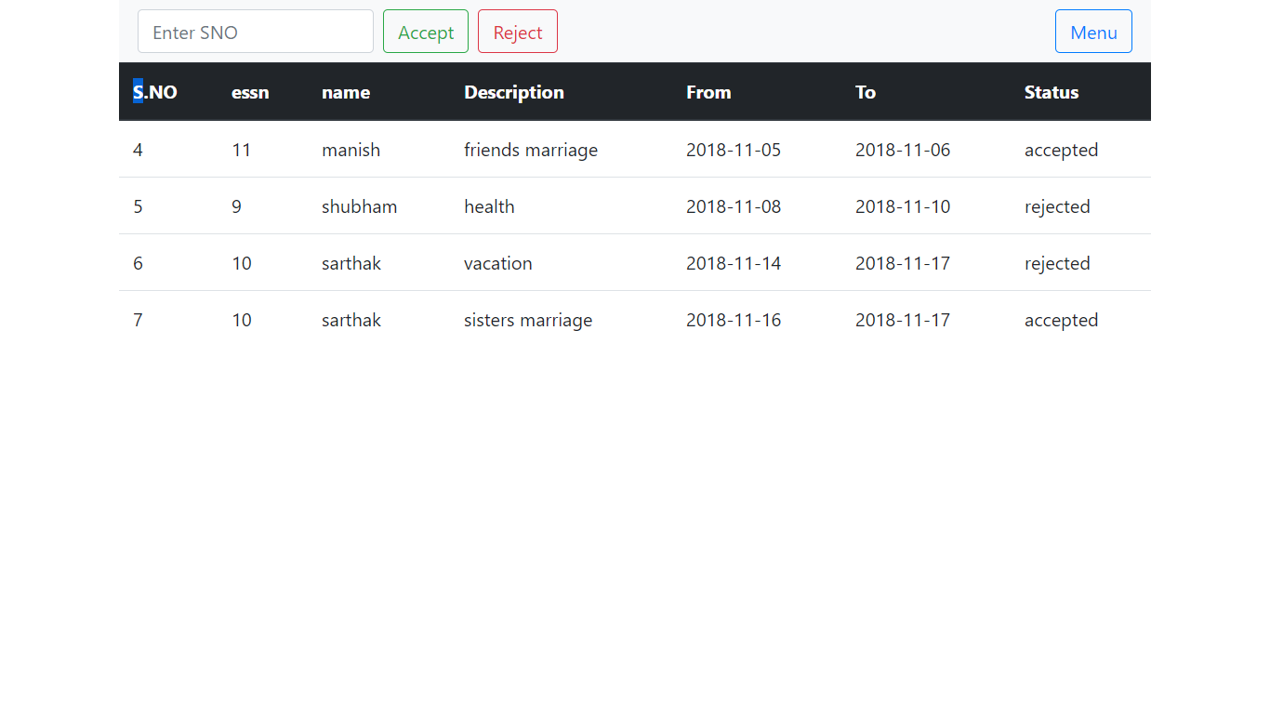 **Fig.6.7 Requests**

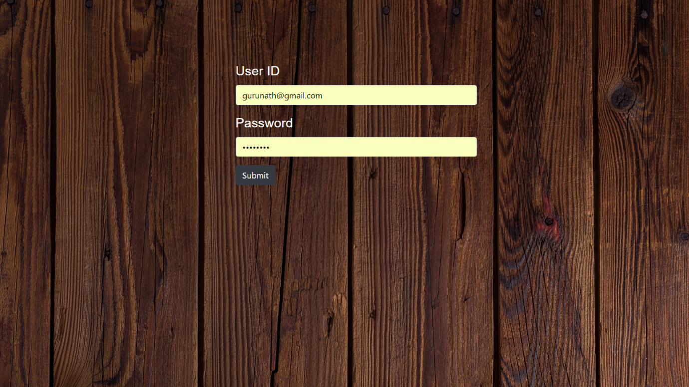

**Fig.6.8 User Login Window**

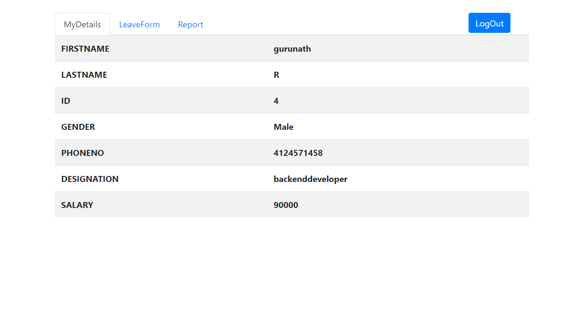

**Fig:6.9 My Details Window**

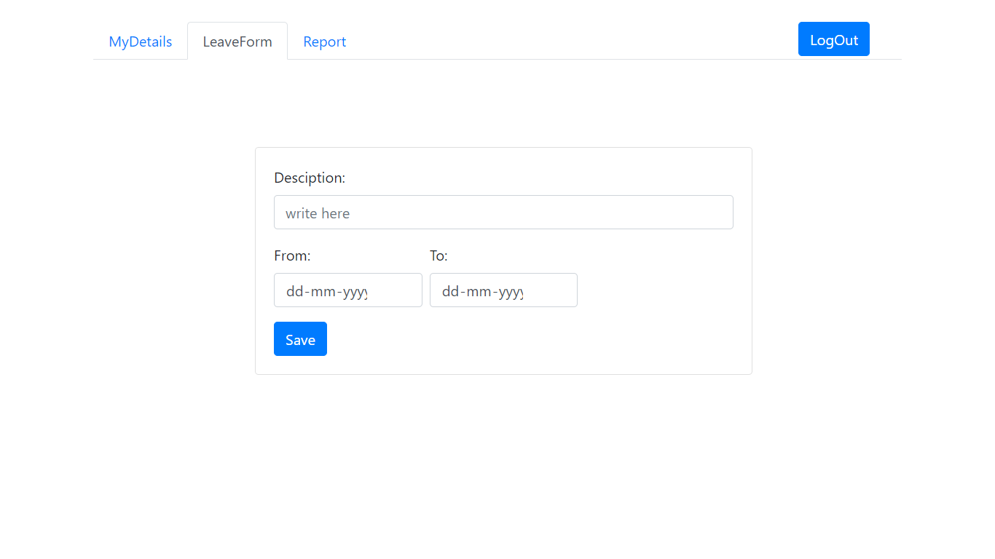 **Fig.6.10 Leave Form Window**

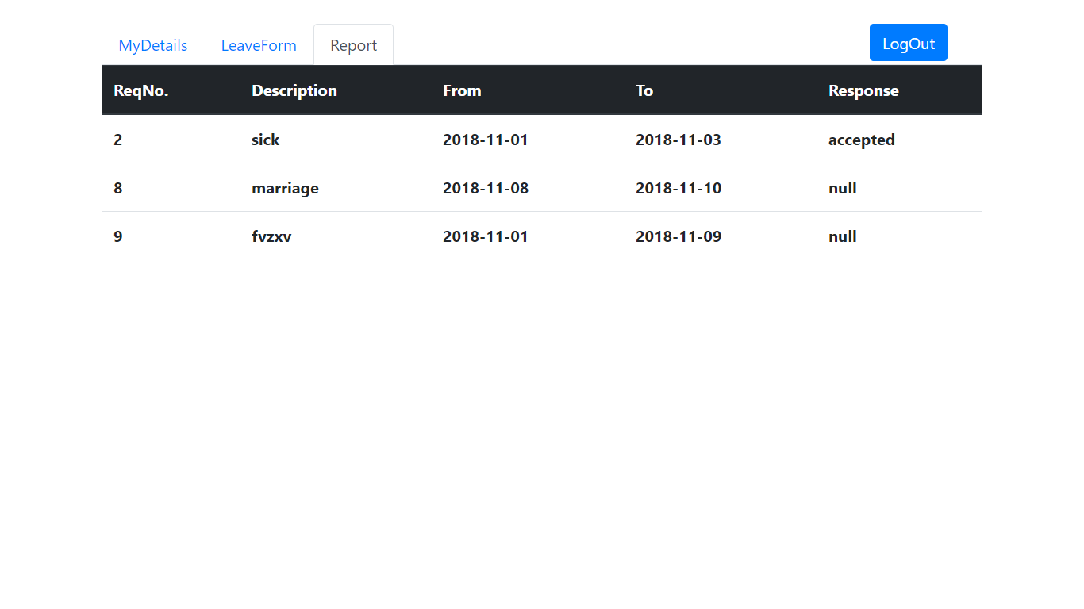 **Fig.6.11 Report Window**

**Chapter 7**

**Testing**

**7.1 Component Test**

**Display Module:**

**Table 7.1 Display Module Test**

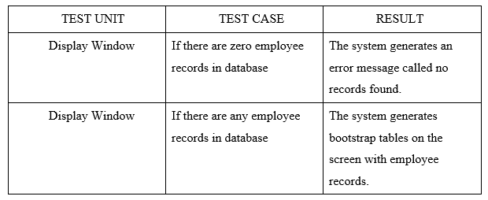

**Register Module:**

**Table 7.2 Register Module Test**

|  |  |  |
| --- | --- | --- |
| TEST UNIT | TEST CASE | RESULT |
| Register Window | Wrong format of information entered into data fields of register page. | The system generates an error message to the user indicating that the wrong format of data is entered. |
| Register Window | Correct data entered into the fields in the register page. | The system will save the given employee details by the user. |

**Delete Module:**

**Table 7.3 Delete Module Test**

|  |  |  |
| --- | --- | --- |
| TEST UNIT | TEST CASE | RESULT |
| Delete Window | Enter incorrect employee id. | System Displays a error message saying invalid employee id. |
| Delete Window | Enter correct employee id. | System deletes the details of the employee having corresponding employee id. |

**Request Module:**

**Table 7.4 Request Module Test**

|  |  |  |
| --- | --- | --- |
| TEST UNIT | TEST CASE | RESULT |
| Request Window | Enter incorrect request number. | System displays a message saying no request number found. |
| Request Window | Enter correct request number. | System will update the status of corresponding request number as accept/reject. |

**Conclusion:**

Since this project has been designed exclusively as a project, certain complexities that do faced by any real-life manual problem like total no. of employee, address redundancy etc. are considered in this project. But enhancement to the project can easily be made without changing the current design and programming structure. Once the project is completed, it provides following functionalities:

After proper authentication, the manager can add new employee, delete employee, update his own password and also can respond to his employee requests for leave. The manager can maintain only the employees working under him. After proper authentication, the employee can check his details, can send request for the leave to his manager, check the response status.

**References:**

* Fundamentals of Database Systems (seventh edition,2016), Ramez Elmasri, Shamkant B.Navathe
* Udemy: [www.udemy.com](http://www.udemy.com)
* W3schools: [www.W3schools.com](http://www.W3schools.com)
* Stack overflow: [www.stackoverflow.com](http://www.stackoverflow.com)
* YouTube: [www.youtube.com](http://www.youtube.com)